IF YOU GO . . .
Want to see a high school sports event but don't know how to get there?
Here is a map plotting the course to 46 high schools (public and private) that are the focus of The Times-Dispatch's prep sports coverage. The four districts that make up the Group AAA Central Region are color-coded.
Rather than attempt to give precise directions - there is no way to have a common starting point - we have listed each school's street address and main office telephone number. This guide can be used in conjunction with a detailed map of the area, including those found on the Internet.
Another alternative is to call the school's office during working hours Monday through Friday and ask for precise directions. Chesterfield schools hours generally are 7 a.m. to 4 p.m. The other counties, Richmond city and the private schools usually are open from 8 a.m. to 5 p.m.
Benedictine has two locations, as the chart shows. The outlying schools are presented in popups with major roads indicated.
Happy traveling.
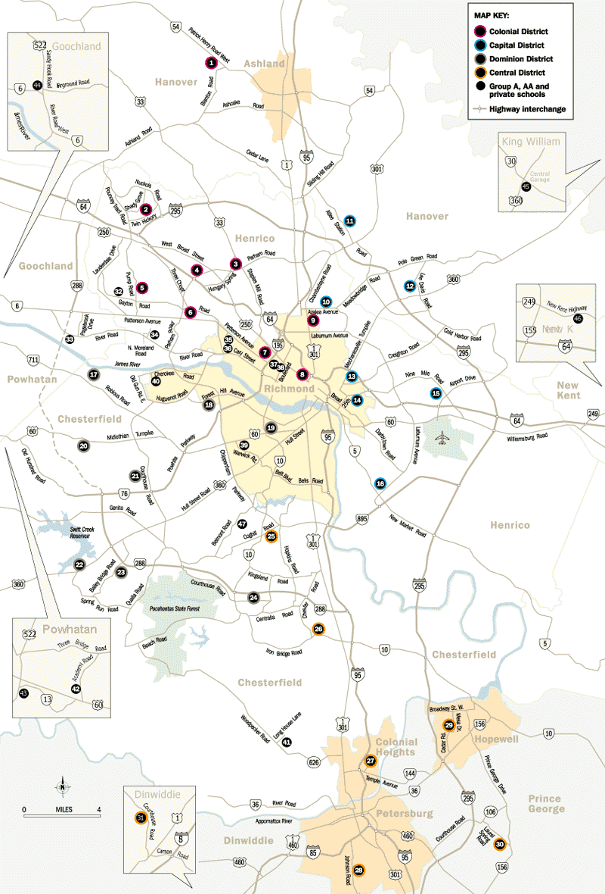

Prep map legend
Here is the key to the numbers on the map on the reverse side of this page, with map number, school name, street address and main office telephone number:

COLONIAL DISTRICT
• No. 1: Patrick Henry - 12477 West Patrick Henry Road, Ashland, 23005; 365-8000.
• No. 2: Deep Run - 4801 Twin Hickory Road, Glen Allen, 23059; 364-8000.
• No. 3: Hermitage - 8301 Hungary Spring Road, Richmond, 23228; 756-3000.
• No. 4: J.R. Tucker - 2910 Parham Road, Richmond, 23229; 527-4600.
• No. 5: Mills Godwin - 2101 Pump Road, Richmond, 23233; 750-2600.
• No. 6: Douglas Freeman - 8701 Three Chopt Road, Richmond, 23229; 673-3700.
• No. 7: Thomas Jefferson - 4100 W. Grace St., Richmond, 23230; 780-6028.
• No. 8: Maggie Walker/Governor's School - 1000 N. Lombardy St., 23220; 354-6800.
• No. 9: John Marshall - 4225 Old Brook Road, Richmond, 23227; 780-6052.

CAPITAL DISTRICT
• No. 10: Henrico - 302 Azalea Ave., Richmond 23227; 228-2700.
• No. 11: Atlee - 9414 Atlee Station Road, Mechanicsville, 23111; 723-2100.
• No. 12: Lee-Davis - 7052 Mechanicsville Pike, Mechanicsville, 23111; 723-2200.
• No. 13: John F. Kennedy - 2300 Cool Lane, Richmond, 23223; 780-4449.
• No. 14: Armstrong - 1611 N. 31st St., Richmond, 23223; 780-4017.
• No. 15: Highland Springs - 15 S. Oak Ave., Highland Springs, 23075; 328-4000.
• No. 16: Varina - 7900 Messer Road, Richmond, 23231; 226-8700.

DOMINION DISTRICT
• No. 17: James River - 3700 James River Road, Midlothian, 23113; 378-2420.
• No. 18: Huguenot - 7945 Forest Hill Ave., Richmond, 23225; 320-7967.
• No. 19: George Wythe - 4134 Crutchfield St., Richmond, 23225; 780-5037.
• No. 20: Midlothian - 401 Charter Colony Parkway, Midlothian, 23113; 378-2440.
• No. 21: Monacan - 11501 Smoketree Drive, Richmond, 23236; 378-2480.
• No. 22: Clover Hill - 13900 Hull Street Road, Midlothian, 23113; 739-6230.
• No. 23: Manchester - 12601 Bailey Bridge Road, Midlothian, 23112; 739-6275.
• No. 24: L.C. Bird - 10301 Courthouse Road, Chesterfield, 23832; 768-6110.

CENTRAL DISTRICT
• No. 25: Meadowbrook - 4901 Cogbill Road, Richmond, 23234; 743-3675.
• No. 26: Thomas Dale - 3626 W. Hundred Road, Chester, 23831; 768-6245.
• No. 27: Colonial Heights - 3600 Conduit Road, Colonial Heights, 23834; 524-3405.
• No. 28: Petersburg - 3101 Johnson Road, Petersburg, 23805; 861-4884.
• No. 29: Hopewell - 400 S. Mesa Drive, Hopewell, 23860; 541-6402.
• No. 30: Prince George - 7801 Laurel Spring Road, Prince George, 23825; 733-2720.
• No. 31: Dinwiddie - 11608 Courthouse Road, Dinwiddie, 23841; 469-4280.

GROUP A, AA AND PRIVATE SCHOOLS
• No. 32: Steward - 11600 Gayton Road, Richmond, 23233; 740-3394.
• No. 33, 38: Benedictine - Mary Mother of the Church Abbey where the athletic fields are located: 12829 River Road, Richmond, 23233; in town (main school and basketball gym): 304 N. Sheppard St., Richmond, 23221, 342-1300.
• No. 34: Collegiate - N. Moreland Road, Richmond, 23229; 740-7077.
• No. 35: St. Christopher's - 711 St. Christopher's Road, Richmond, 23226; 282-3185.
• No. 36: St. Catherine's - 6001 Grove Ave., Richmond, 23226; 288-2804.
• No. 37: St. Gertrude - 3215 Stuart Ave., Richmond, 23221; 358-9114.
• No. 38: Benedictine (see No. 33 above)
• No. 39: Commonwealth Christian - 6255 Warwick Road, Richmond, 23224; 276-6300.
• No. 40: Trinity Episcopal - 3850 Pittaway Road, Richmond, 23235; 272-5864.
• No. 41: Matoaca - 17700 Long House Lane, Chesterfield, 23838; 590-3108; (football field is at the old school, 6001 Hickory Road, this season).
• No. 42: Blessed Sacrament Huguenot - 2501 Academy Road, Powhatan, 23139; 598-4211.
• No. 43: Powhatan - 4135 Old Buckingham Road, Powhatan, 23139; 598-5710.
• No. 44: Goochland - 3250 River Road West, Goochland, 23063; 556-5322.
• No. 45: King William - 80 Cavalier Drive, King William, 23086; 769-2708.
• No. 46: New Kent - 7504 Egypt Road, New Kent, 23124; 966-2771.
• No. 47: Richmond Christian - 6511 Belmont Road, Richmond, 23234; 276-3193.

